Vomiting in pregnancy.
Early pregnancy
*Simple vomiting
*Hyperemesis gravid arum
Associate with other disease.
*Medical: UTI, hepatites, Keto acidosis, Helmenthiasis
*Surgical: Appendicitis, Cholecystitis, Pancreatitis, Peptic ulcer,
*Gynaecological: Twisted ovarian cyst, Red degeneration of fibroid

*Late pregnancy : Continuous or reappearance of vomiting, Pre-eclumpsia, associated medical, surgical gynaecological disease.
Simple vomiting :
Management:
Doxylamine+pyridoxine,
meclizine+pyridoxine,
ondansetron,

Hyperemesis gravidarum: It is a severe type of vomiting of pregnancy which has got deleterious effect on health of mother and or incapacitates her day to day activates.
The adverse effects are severe vomiting,-dehydration, metabolic acidosis or alkalosis, electrolyte imbalance and weight loss.
Incidence: i/1000, which is decreasing day by day,

Aetiology: limited in 1st trimester.
common in 1st pregnancy
Younger age,
Low body mass
History of motion sickness, or migraine.
A family history,
Hydratidiform mole or twin pregnancy,
Unplanned pregnancy,

Theories:
Hormonal
Psychogenic
Dietrich deficiency
Allergic or immunological
Decrease gastric motility

Pathology:
Liver, kidneys, heart ,brain.
Metabolic,
Biochemical
Circulatory changes

Clinical courses.
Symptoms :vomiting, oliguria, epi gastric pain ,constipation.
Signs : Dry lounge, eye sunken ,acetone smell in breath, tachycardia
,hypotension, raise temperature & jaundice.

Investigations:
Urine analysis
Bio chemical analysis
Serum T3,T4,TSH
Ophthalmoscopy
ECG

Diagnosis
Conformation of pregnancy,
Ultrasonography to exclude medical, surgical, and other gynaecological cause.
D/D

Complications
Neurologic
Stress ulcer stomach
Oesophageal tear
Jaundice
Convulsion ,coma
Hypo prothombinimia
Renal failure

Effect on foetus: Unaffected, low birth weight, Preterm labour
Prevention:
Small amount & frequent interval
Drink fluids between meal not with meals
Not to lie immediately after meal
Avoid foods that causes gastric irritation.
Avoid foods that tigers nausea & vomiting.
Management:
Principles of management,
*Maintenance of hydration
*Control of vomiting
*Correct the fluid and electrolyte balance
*Correct metabolic disturbance(acidosis& alkalosis)
*Prevent serious complications
*Care of pregnancy
Hospitalization
Fluids
Drugs,
Nursing care,
Clinical feature of improvement:
Subsidence of vomiting, feeling of hunger, better look

Physiological changes in pregnancy.

1,Changes in the genital organs
2.Haemodynamic changes.
3.Cardiovascular changes
4.Changes in hormone activites.
5.Weight gain
6. Changes in the breast
8.Metabolic changes.

Aim of the changes: Maternal adaptation to increase the demand of the growing foetus
a)Haematological changes
*Blood volume increase from 6th week to 32 week is 30-40% above the non pregnant level
*Plasma volume increase 1.25 litre(40-50%).
*RBC volume increase 350 ml (20-30%)
*Haemodilution due to decrease haemoglobin 2gm%,causes physiological anaemia.
*Increase WBC,10,000-20,000/mm3
*Increase total protin from180gm to 230 gm at term.
* Albumin and globulin ratio become A:G 1:1 from 1.7:1.
*Increase fibrinogen level, high ESR, no change in clotting time.

- CVS changes in pregnancy
Cardiac output
*Cardiac out put increase from 5th week s of pregnancy reaches to peak 40-50% at about 33-34 weeks.
*Cardiac out put 50% increase during labour, immediately after delivery+70%.
*Increase cardiac output due to increase blood volume, oxygen demand,& metabolic activites.
*Return to pre labour value after one hour, and pre pregnancy state after 4 week

Changes in blood pressure
*Decrease BP due to decrease pheriferal vascular registance due to progesterone .NO. prostaglandin)
Venous pressure:Femoral BP in nonpegnant state 25mm water increase
80-100mmwater.

Changes in pulse rate
*Slightly increase in pulse rate

Endocrine changes in pregnancy:
placental hormones
a)Steroid hormones
oestrogen,progesterone,cortisol.

b)Protin hormones&factors
1)Pituitary like hormone
# Human chorion gonadrotopic hormone,
# Human placental lactogen
#Human chorionic thyrotropin
# ACTH

2)Hypothalamic like hormones
# Corticotrophin releasing hormone
# Gonadotrophin releasing hormones
# Thyrotrophin releasing hormone
# Growth hormone releasing hormone
3)Growth factors
# Inhibin
# Activin
#Trans forming growth factor
#Epidermal growth factor

4)Other pregnancy protein
# relaxin
# Prolatin
#Early pregnancy factor

Functions of Human chorionic gonadotropins (hCG) :
- It acts as a stimulus for the secretion of progesterone by the corpus luteum of pregnancy. The rescue and maintenance of the corpus luteum till 6 weeks of pregnancy is the major biological function of hCG.
- hCG simulates Leydig cells of the male fetus to produce testosterone in conjunction with fetal pituitary gonadotropins. It is thus indirectly involved in development of male external genitalia.
- It has got immune-suppressive activity which may inhabit the maternal processes of immunorejection of the fetus homograft.
Functions of steroid hormones (estrogen & progesterone) : Together they play an important role in the maintenance of pregnancy .
- Estrogen causes hypertrophy & hyperplasia of the uterine myometrium, thereby increasing the accommodation capacity and blood flow of the uterus. Progesterone in conjunction with estrogen simulates growth of the uterus, causes decidual changes of the endometrium required for implamentation and it inhabits myometrial contraction.
- Hypertrophy & proliferation of the ducts are due to estrogen, while those of lobulo-alveoro system are due to combined action estrogen and progesterone.

Weight gain in pregnancy
Total weight gainin-11kg.in a single pregnancy.(1+5+5)
Reproductive weight gain 6kg Maternal weight 6 kg
Fetus 3.3kg , Blood volume-1.3kg
placenta-0.6 kg, ECF -1.2kg
liqor-0.8kg, Fat&protin -3.5kg
breast-o.4,
uterus-.0.9kg
Rapid weight gain>2.2kg/month is a sign of PE,
falling weight –IUGR,IUD
Dispropotionate weight gain –Multiple pregnancy.

Importance of weight gain
Parameter of nutritional status
Progress of maternal weight
Rapid weight gain & poor weight gain both are pathological

Breast changes in pregnancy
a)First trimaster change
Feeling of fullness& prickling sensation in 6-8 weeks
Enlargement with vascular engagement specially in delicate vein under the skin.
b)2nd trimester
-More enlarge &prominent vein under the skin
-Colostrum become thick &yellowish in16th week.
-Secondary areola demarcated specially in primigravida appears at about 20week
Montgoery tubercles are prominent extend up to the 2ndary areola
-Variable degree of stria apears in the skin of breast.

Metabolic changes
Total metabolic changes increases. BMR incrses30%
a)Protein: Positive nitrogen balance. Pregnancy is an anabolic state.
b)Carbohydrate metabolism Transfer increased amount of glucose to the foetus. Increase secretion of insulin. Decrease sensitivities of insulin 44%.overall effect is maternal fasting hypoglycaemia
c)Fat metabolism: Average 3-4 kg fat stored during pregnancy.
d)Iron metabolism Absorb in ferric form. only 10%iron absorb. Total need 1,000mg during pregnancy.
e)Calcium: Increase demand ofcalcium28gm .80%required in last trimester for bone mineralization. Daily requirement is 1-1.5gm calcium.

Diagnosis of pregnancy
- Amenorrhoea: Cesation of menstration caused bypresence of estrogen & progesterone secreted from corpuslutium.
- Nausea& vomiting: 50%mothers suffers from nausea & vomiting.starts at 2nd week and ends 13th to 14th weeks.
- Breast change
a)Mastodynia : Breast tenderness tingling to pain sensation due to hormones affecting themammary duct and alveolarsystem.
b)Breast engorgement : Breast engorgement and peri areolar venous prominence specillay in primypara .Montogomaries tubercle is visible usually occurs in 6 to 8 weeks.
c)Colostrum secreation : Protein and antibody product may secreats as early as 16 weeks gestation.
d)Devlopment of secondary breast tissue :Secondary breast tissue may be hyper trophid in axilla.
D.Foetal Movement : initial perception of fetal movement in 18 -20 weeks in primy and 14 -16 weeks in multy.
E. Raised Basal-body temperature : Progesteron increase the BTT to 0.5degreeF.
F. Skin changes
a)Chloasma: Skin darkenging of the fore head,breeze of the nose ,or cheek bones usually occurs after 16 weeks.
b)Linea nigra :Malanocyte stimulating hormone causes darkening in lower mid line from umbilicus to the pubis.
c)Striae: Striae marks of the breast and abdomen parallel thin streaks of red ,glossy skin that become scar lines. These streach appear at late pregnancy and are formed by abnormal collagen formation and separation.
d)Spider telangiectasia :Skin lesion of pregnancy resulting from raising plasma estrogen in vascular stellate skin lesions
G. Pelvic organ changes
a) Chadwics Sign: Congestion of the pelvic vasculature causes bullish discoloration of the vagina and cervix
b) Hagers Sign: There is widening and softening of the uterus and cervix and dilatation of the cervix occur due to estrogen and progestron. It occurs at 6—8 weeks of pregnancy.
c) Leukorrhea :Vaginal secreation increase containing epithelial cell and cervical mucus.
d) Abdominal enlargement: Progressive abdominal enlargement with growth of the uterus in pregnancy . From18 to 34 weeks pregnancy there is a good correlation between uterine fundal height measuring in centimetre and gestational age in week.
e)Uterine contractions: Painless uterine contraction Braxton Hicks contractions usually beguns at 28 weeks gestation do not cause cervical dilatation. These pain causes labour pain later.
Diagnosis of pregnancy
--Fetal heart sound :Detectable after 10 weeks by Dropiar and by fetoscope aeter 18-20 weeks .Normal heart range is 110-160 beat/min.
--Uterine size/Fetal palpation: At 12 weeks uterus lies above the symphysis ,Fetal parts felt after 22weeks.
--USG :Cardiac activites detectable in 6 weeks by TVS The embrio appears human like in 10 weeks by LMP.
--Pregnancy test
a)Home pregnancy test:Due to bHCG may be detect able in serum at 6 -12 days after conception.20-22days after LMP
b)Urine pregnancy test(Laboratary)
C)Serum pregnancy test.
GESTATIONAL AGE DETERMINATION.
A)Pregnency calendar or calculator.
B)Clinical parameters.
a)Uterine size.
b)Quickening.
c)Fetal heart sound
d)Ultrasound.

High Risk Pregnancy
High risk pregnancy is one which is complicated by factor or factors that adversely affect the health of the pregnancy outcome-maternal or perinatal or both.
Incidance- 20-30% .50%maternal complications and 60% of all primary c-section arise from the highrisk group case.
High Ris k pre gnancy
1)Elderly primy (>30 years age)
2) Short stature primi(>140 cm)
3)Threatened abortion
4)Ante partum haemorrhage
5)Malpresantation
6)Preeclamsia-eclamsia
7)Anaemia
8)Elderly grand multiparas
9)Twins and polyhydramnion
10)H/O previous still birth,IUD,IUGR,manual removial plac
centa
11)H/O previous caesarean section and instrumental delivery
12)Prolong pregnancy
13)Pregnancy associated with medical disease
During labour
1)PROM
2)Prolong labour
3)Hand, feet,cord prolapse
4)Placenta reained more than 30minutes
5)Post partum haemorrhage
6)Puerperal fever &Sepsis

Diagnosis or screening of high risk cases :
History taking :
- Maternal age
- Family history:
  - Socio-economic condition : Poor socio-economic status has a high incidence of anaemia, IUGR, preterm labour etc.
  - Women who undertake frequent long journeys have a higher incidence of recurrent abortion or preterm labour.
  - Family history of diabetes mellitus, hypertension, multiple pregnancy (maternal side), congenital anomalies.
- Reproductive history : 2nd & 3rd pregnancies after a normal delivery carry low risk.
High risk factorsin reproductive history
  - Two or more previous spontaneous / induced abortion.
  - Previous still birth, neonatal death or birth of babies with congenital anomaly.
  - Previous preterm or small for date or big baby (more than 3 kg) delivery.
  - Grand multiparity.
  - Previous caesarean section or hysterotomy.
  - Pre-eclampsia or eclampsia.
  - Third stage abnormalities : This has a particular tendency to recur.
  - Previous infant with RH-isoimmunisation or ABO incompatibility.
- History of medical disease :
  - Pulmonary disease (e.g. TB)
  - Viral hepatitis.
  - Cardiac disease.
  - Renal disease.
  - Thyroid disease.
  - Psychiatric diseases.
  - Epilepsy.

- Past surgical history :
  - General examination:
    - Height: Lower or equal to 150 cm.
    - Weight: Overweight and underweight both are risk factors. BMI (wt/ht²) = 20 – 24 is normal.
    - High blood pressure.
    - Anaemia.
    - Cardiac or pulmonary diseases.
    - Orthopaedic problem.

  - Per-abdominal examination:
    - Uterine size: Disproportionately smaller or bigger.
    - Genital prolapse.
    - Laceration or dilatation of the cervix.
    - Associated tumour.
    - Pelvic inadequacy.
- Investigations:
1)Blood for group& Rh typing
2)Blood for Hb%
3)2hours post parenteral blood sugar
4)Urine for R/E &M/E
5)USG of pregnancy profile.
- Neonate at high risk:
  - Apgar score below 7.
  - Hypoglycaemia.
  - Anaemia.
  - Birth weight less than 2.5 kg or more than 4 kg.
  - Major congenital abnormalities.
  - Convulsions.
  - Fatal infections.
  - Jaundice.
  - Respiratory distress syndrome.
  - Persistent cyanosis.
  - Haemorrhagic diathesis.

Ante natal care
Defination: Systematic suvervision (Examination and advice) of a woman during pregnancy is called antenatal care,

Aims of the atenatal care:
1)To screen out the high risk cases.
2)To prevent or to detect &treat at the earliest any complications.
3)To ensure continued medical surveillance and prophylaxis
4)To educate the mother about the physology of pregnancy &labour by demonstration of charts& diagram to remove the fear and improve psychology of mother.
5)To discuss with the couple about the place ,time &modes of delivery, provisionally & care of the new born.
6) To motivate the couple about the need of family planning
Objectives
To ensure a normal pregnancy with delivery of a healthy baby from a healthy mother& to avoid foetal death
To reduce maternal mortality and morbidity & perinatal mortality and morbidity.
1)Toasses the health status of the mother & and the fetus.
2)To asses the foetal gestational age&to obtain baseline investigations
3)To organise continued obstetric care and risk assessment.

values/ importance/advantage of ANC care.
1)To screen out high risk cases
2)Detection of high risk factors
3)Regular supervision of pregnancy
4)ANC is said to be the strategy and intra natal care is the tactis in obstetrics
5)Acceptance of advice
6)To make the patient realise that the pregnancy is a physiological process and give the psychological support.

Ideal schedule antenatal checkup
*1st visit as earlyb in pregnancy as likely
*Every 4 weeks up to 28 weeks
*Every 2 weeks up to 36 weeks
*Every week up to delivery.
*More visit if any complications arise.

WHO recommended schedule of antenatal care
- 1st visit in16 weeks
- 2nd visit between 24-28 weeks
- 3rd visit at 32 weeks
- 4th visit at 36th weeks

Management of 1St antenatal chequeup
History taking :
1)Particulars of the patient: name, age, religion, occupation, address.
2)History of present illness:Period of amenorrhea.plus anyother complications,
3)HIstory of past illness:Past medical/surgical/obstetrical causes
4)Family history:Familly history of DM,HTN,bronchial asthma
5)Personal History:
6)Drug history:
7) Immunization history:
8)Socio-economic history : Poor socio-economic status has a high incidence of anaemia, IUGR, preterm labour etc
9)Menstrual history:
-Age of menarche
-Menstrual cycle(MC )
-Menstrual period(MP)
-Flow
-LMP
-EDD
10 ) Obstetrical history
-Duration of marrage
-Para,
-Gravida,
-Age of last child

11)Clinical Examinations
A) General examination:
    - Body built
    - Nutritional status
    - Height
    - Weight:
    - Pulse.
    - Blood pressure.
    - Respiratory rate
    - Temperature
    - Anaemia
    - Jaundice
    - Cyanosis
    - Oedema
    - Dehydration
    - urine output

B) Per-abdominal examination:
a)Inspection: Shape of the abdomen , stria, scar marks
b)Palpation:
*Hight of the uterus
*Fetal movement
*For grips: Fundal ,two lateral grip,& pelvic grip
c)Auscultation :Fetal heart rate
C) Other system examination
*Cardio vascular system
*Respiratory system
D)Per-vaginal examination:

12)Investigations(Routine examination ):
a) 1)Blood for group& Rh typing
2)Blood for Hb%
3)2hours post parenteral blood sugar
4)Urine for R/E &M/E
5) Blood for Hepatises(HbsAg)
6)Blood for VDRL
5)USG of pregnancy profile

b) Repetiation of the examinations: Should do in every antenatal visit
1)Hb%
2)Urine for R/E.

Normal Labour

Labour :Series of events that takes place in the genital organs in an effort to expel the viable products of conception out of the womb though the vagina in to the outer world after 28 weeks of pregnancy.
Delivery : The expulsion or extraction of a viable fetus out of the womb.

Normal labour : Labour is called normal if it fulfil the criteria:
1.Spontenius in onset at term.
2.With vertex presentation.
3.Without undue prolongation.
4.Natural termination with minimal aid.
5.Without having any complications affecting health of the mother and or the fetus.

Prolonged labour

The labour is said to be prolonged when the combined duration of the 1st & 2nd stage is more than the arbitrary time limit of 18 hours.
WHO-1994 definition
Labour is considered prolonged when the cervical dilation rate is less than 1 cm/ hour and descent of presenting part is less than 1 cm/ hour for a period of minimum of 4 hours of observation.
Prolonged latent phase:
A latent phase that exceeds 20 hours in primigravida or 14 hours in multipara is abnormal.
Causes of prolonged latent phase:
- Unripe cervix.
- Malposition and malpresentation.
- Chephalopelvic disproportion.
- PROM
- Induction of labour
- Early use of regional anaesthesia.

Management:
- Expectant management
- Rest, analgesic and augmentation.
- C-section if necessary.

Causes of prolonged labour
- 1st stage:
- Fault in power:
- Abnormal uterine contraction.
- Incoordinate uterine contraction.
- Fault in passage:
- Contracted pelvis.
- Cervical dystocia.
- Pelvic tumour.
- Fault in passenger:
- Malpresentation.
- Malposition.
- Others:
- Injudicious administration of sedatives and analgesics.
- 2nd stage:
- Fault in power:
- Uterine Inertia.
- Inability to bear down.
- Epidural anaesthesia.
- Constriction ring.
- Fault in passage:
- Pelvic abnormality. Eg. Cephalo-pelvic disproportion (CPD), android pelvis & contracted pelvis.
- Undue resistance of the pelvic floor.
- Soft tissue pelvic tumour
- Fault in passenger:
- Malpresentation.
- Malposition.
- Big baby.
- Congenital abnormalities.

Management of prolonged labour
- Diagnosis
- First stage: Criteria for prolonged 1st stage are:
- Duration: >12 hours.
- Rate of cervical dialation:
- Primi: <1 cm/hour
- Multi: <1.5 cm/hour

- Rate of descent:
- Primi: <1 cm/hour
- Multi: <2 cm/hour
- Second stage:
- Duration:
- Primi: >2 cm
- Multi: >1 cm
- Diagnostic features:
- Sluggish or non-descent of the presenting part even after full dilation of the cervix.
- Variable degrees of moulding & caput formation in cephalic presentation.
- Identification of the cause of prolongation.
- Clinical examination:
- Clinical Pelvimetry is done
- P/V examination is done to verify the foetal preservation, position and station.
- Investigations: Diagnosis is mostly clinical & role of investigation is little.

- Treatment
- Preventive management:
- Antenatal or early intranatal detection.
- Use of partograph.
- Selective and judicious augmentation.
- Emotional support.
- Avoidance of dehydration.
- General treatment:
- Strict maintaining of WHO modified paragraph.
- Nothing by mouth.
- O₂ inhalation: If maternal or foetal distress present.
- If dehydration: I/V fluid (Ringers lactate, Hartman’s solution or normal saline)
- If acidosis: 25% Sodium-bi-carbonate I/V 8 hourly.10%D/A.
- Antibiotic: If membrane ruptures & there are possibilities of infection.
- Catheterization: To monitor urine output (for 14-21 days to rest to the bladder & urethra to prevent VVF).
- Specific treatment:
- First stage delay:
- Amniotomy &/or oxytocin infusion to argument the labour.
- Pain relief: By I/M pathedine or epidural analgesia.
- In secondary arrest: Oxytocin should be used cautiously.
- Caesarean section: Treatment of choice in maximum cases specially associated with malpresentation, malposition, big baby, CPD or where NVD is not possible.
- Second stage delay:
- Expectant treatment is risky as there is chance of foetal distress or still birth.
- Short duration expectant treatment maybe allowed if FHR is good (clinically difficult to do).
- Assisted vaginal delivery (need expert obstetrician).
- Clinically caesarean section is done in maximum cases (as it is more safe & relatively quick to act & satisfactory outcome for both mother & foetus).
- Dead baby CS should be avoided, vaginal delivery is highest priority.

Complications of prolonged labour:
- Foetal complications:
- Hypoxia:
- Intra uterine infection:
- Intra-cranial stress or haemorrhage:
- Increased optative delivery.
- Foetal acidosis.

- Maternal complications:
- Maternal distress.
- Post-partum haemorrhage.
- Trauma to the genital tract.
- Increased optative delivery.
- Puerperal sepsis.
- Subinvolution.

Obstructed labour

When the progressive descent of the presenting part is arrested due to mechanical obstruction in spite of good uterine contractions is called obstructed labour.

Causes of obstructed labour
- Fault in passage/ maternal factors:
- Bony factors:
- Contracted pelvis.
- Cephalo-pelvic disproportion (CPD).
- Secondary contracted pelvis in multiparous women.
- Soft tissue factors:
- Cervical dystocia.
- Previous operation scarring.
- Cervical or broad ligament fibroid.
- Impacted ovarian tumour.
- Non-gravid horn of a bicornuate uterus below the presenting part.
- Injudicious administration of sedatives and analgesics.
- Fault in passenger/ foetal factors:
- Transverse lie.
- Brow presentation.
- Congenital malformation: Hydrocephalus (common), foetal ascites, double monsters etc.
- Big baby, occipito-posterior position.
- Compound presentation.
- Lock ed twins
Management of obstructed labour
- Clinical presenntion:
- History:
  - History of prolongation of labour in spite of onset & continuation of true labour pain (which is the evidence of good uterine contraction).
  - Failure in progress of labour in spite of good uterine contractions for a reasonable period (2-4 hours) in an impending sign of obstructed labour.
  - Previous history of prolonged labour.
  - History of C/S due to obstructed labour.
  - Short stature.
  - Hypertension, diabetes mellitus.

- General examination:
- Height: Short stature.
- Patient may be exhausted.
- Hyportension, tachycardia.
- Tachypnoea.
- Signs of dehydration: Dry tongue, dry skin, hypotension, tachycardia, low urine output etc. may be present.
- Ketoacidosis may be present.
- Signs of shock (haemorrhage): May be present in case of ruptured uterus.
- Pre-abdominal examination:
  - Foetal Heart sound: Signs of foetal distress or even absent FHS.
  - Height of the uterus: Decreased (as there is rupture of membreanes).
  - Lateral grip: Foetal head & back may be palpated (transverse lie).
  - Fundal grip: Head is palpated. (breech presentation).
  - Feeling of uterus: Hard (i.e. contracted)
  - Abdominal findings of CPD may be found.

- Pre-vaginal examination:
  - Inspection: Vagina is found to be oedematous & dry.
  - Palpation:
- Membranes are ruptured.
- Dry, hot & oedematous vagina.
- Oedematous cervix is loosely applied to the presenting part.
- Cervix: Fully dilated.
Investigations
- USG: No role in current situation
- Blood for Hb%,grouping &Rh typing.
- RBS
- Treatment
    - Principles of treatment
1)Correction of dehydration& ketoagidosis.
2)Control of infection & sepsis.
3)Mannagement of shok ih case of ruptured uterus.
4) To relieve of obstruction at the earliest by a safe delivery procedure.

B)General Management:
1)Nothing by mouth.
2)O₂ inhalation: If maternal or foetal distress present.
3)Catthetarization:
3)If dehydration: I/V fluid (Ringers lactate, Hartman’s solution or normal saline)
4)If acidosis: 25% Sodium-bi-carbonate I/V 8 hourly.10%D/A.
5) Antibiotic: I/V broad spectrum antibiotics

- C) Obstetrical management: There is no place of Wait&Watch,no use of scope of using oxytoctn.Internal version is strictly prohibited.
      - Vaginal delivery:
*If head is low FHS is good & vaginal delivery is not risky Ventouse delivery .
*In neglected cases even with FHS is audible vaginal delivery is the treatment of choice.
*Dead baby : destructive operation.
b) Caesarean section:
*With good fetal condition C/S is the best.
*Trnsverse lie or shoulder presentation C/S is solve the problame

Complications of prolonged labour:

- Maternal complications:
Immidate :
1)Exhaustion
2)Dehydration
3)Metabolic acidosis
4)Genital sepsis
5)Rupture of the uterus
6)Postpartum haemorrhage & shok
7)Increase operative menupulation.
Remote complication
1)VVF
2)Vaginal atretia
3)PID.

Foetal complications:
a)Asphyxia:
b)Intra-cranial stress or haemorrhage:
c)Foetal acidosis.

Ruptured uterus

Rupture of the uterus :
Disruption in the continuity of the uterine wall any time beyond 28 weeks of pregnancy is called rupture of the uterus.

Incidence: 1in200 delivery to 1 in2000 deliveries.

Etiology
Causes of rupture of the uterus are broadly devided into
*Spontaneous
*Scar ruptured
*Iatrogenic

During pregnancy

a)Scared uterus
*C/S scar
*Hystrotomy
*Previous manual removal placenta
*Previous H/O of D&C

b)Spontaneous
*Multipara
*Congenital malformation of uterus
*Abruptio placenta
*Perforating mole
*Placenta percreata
c) Iatrogenic
*Fall or blow
*Use of oxytocic
*Use of prostaglandin
During labour
a)Scared uterus
*C/S scar
*Hysterotomy
*Previous H/O repair of ruptured uterus.
*Previous H/O corneal resection of ectopic pregnancy . b)Spontaneous
* Grand multipara
*Congenital malformation of uterus
*Obstructed labour

c) Iatrogenic
*Vaginal operative delivery
*Internal version
*Manual removal of placenta
*Use of oxytocic

Most common causes of ruptured uterus
- Grand multiparty
- Obstructed labour
- Injudicious use of oxytocic’s
- Ruptured weak scar of previous C/S or hysterotomy.
- Previous H/O of manual removal of placenta
- Direct trauma.
- Instrumental delivery

Management of ruptured uterus

Diagnosis:
  - History:
    - There is a scene of something giving way at height of uterine contraction.
    - Sudden onset, severe, sharp, agonizing & tearing lower abdominal pain which may be continuous, significantly non-radiating & persists even between uterine contractions.
    - Per-vaginal bleeding: Moderate to severe.
    - Patient is usually multiparous.
    - History of Oxytocin or prostaglandin for augmentation or induction of labour.
    - In obstructive rupture: Features of obstructive labour present.
    - In non-obstructive labour: Patient is multiparous.
    - In scar rupture: H/O previous C/S, D & C, manual removal of placenta under G/A, myomectomy, hysterotomy etc. are present.
    - There may be constitutional symptoms; such as vomiting, fever etc.

- Clinical examination:

  - General examination:
    - Patient toxic & exhausted.
    - Anaemia: Moderate to severe.
    - Signs of Hypovolemia (Haemorrhagic) & Dehydration.
    - Signs of Ketoacidosis may be present.
  - Per-abdominal examination:
    - Superficial fetal parts.
    - Fetal Heart sound: Absent or signs of severe fetal diseases may be present.
    - Two separate swelling: One contracted uterus & the other fetal ovoid.
  - P/V examination:
    - Varying degrees of P/V bleeding.
    - Recession of presenting parts.
    - No bag of membranes.
    - Dry, hot & oedematous vagina due to obstructed labour.

- Treatment:
  - Principals of treatment:
    - Correction of Dehydration and Ketoacidosis.
    - Restoration of blood volume by blood transfusion.
    - Control of infection and sepsis.
    - Emergency laparotomy with presence of senior obstetrician & an expert general surgeon.

  - Resuscitation / General treatment: Resuscitation & arrangement of emergency laparotomy should be stated simultaneously.
Nothing by month.
    - Oxygen inhalation: If maternal respiratory distress.
    - I/V fluid: Hartman’s solution, Normal saline, Ringer’s lactate, & 5% DNS.
    - Blood is sent for grouping and Rh typing.
    - Blood transfusion (at least 2-4 unit of blood) should be transferred as early as possible after cross-matching & donor should be readied for further transfusion.
    - Acidosis: 25% Sodium-bi-carbonate I/V tds.
    - Antibiotic: Inj. Ceftriaxone (2 gm, I/V od) or Cephredine (500 mg, I/V qds) or Cefepime (2 gm,I/V bd) + Inj. Metronidazole (500 mg, I/v tds).
    - Analgesic: Inj. Pethedin (100 mg, I/V or I/M) also reduces anxiety.
    - Catheterization: To monitor urine output.

  - Laparotomy / Obstetric treatment:
    - Hysterectomy (total/subtotal):
- Badly injured uterus, which is impossible to repair.
- Spontaneous obstructive rupture
- Family complete.
    - Repair:
- Scar rupture, where the margins are clean.
- When family is not complete.

    - Repair & Sterilization:
- Clean cut scar rupture with complete

POST - TERM OR POST MATURITY
Postmaturity is defined as pregnancy continuing beyond two weeks of expected date of delivery is called post maturity.
Literaly any pregnancy which passed beyond the EDD is called postdated pregnancy.
Incidence rate: 4-14%(10%)

Causeses of postmatyrity
a)Wrong dates: In accurate LMP
b)Hereditary
c)Fetal factors : Anencephaly
d)Placental factors :Estrogen deficency
e)Maternal factors
*Primigravida
*Previous prolong pregnancy
*Sedentary habit
*Elderly multipara

*Menstrual history Management of Post maturity
A)Diagnosis of post maturity
a)History and clinical examination

*Examination of the girth of the mothers abdomen
*Regular weight checking
*Obstetric palpation :Full of foetus
*P/V Examination: Hard skull bones
b)Investigations
*USG of pregnancy profile
*Amniocenteces
*RBS
B)Treatment of postmaturity: Immediate termination of pregnancy
* Complicated case : C/section is the treatment of choice.

*Un complicated case
a)Favourable cervix: Induction of labour by striping or byARMand added oxytocin infution.
b)Unfavourable cervix: Ripening of the cervix by PGE2 followed by induction of labour by ARMand oxytocin infusion if the length of the cervix is <25 mm
c)Care during vaginal delivery:
*The labour expected to be prolong ,so there is chance of fetal distress.
*There is possibility of shoulder dystocia
*More analgesia may be required for analgesia.
*More chance of use ventouse delivery/forceps delivery.
Complications of postmaturity:
- Fetal complications
A)During pregnancy
1)Diminished fetal function.
2)Oligohydramnions
3)Muconium stained liquor.
B)During labour
a)Fetal hypoxia&acidosis
b)Muconium aspiration
c)Shoulder dystocia
d)Dysfunctional utrine contraction
e)Risk of cord compression due to olgohydrmnion
f)Increased incidence of birth trumma
g)Increased incidence of operative delivery

C)Following birth
a)Chemical pneumonoitrs,pulmonary collapse,& pulmonaryHTN may devlop due to meconium aspiration.
b)Fetal hypoxia
c)Hypoglycemia,
d)Perinatal morbidity&mortality

- Maternal complications
a)Anxity
b)Dystocias & prolonged labour
c)High operative interference.
***

PARTOGRAPH

Partograph is a composite graphical record of key data (maternal &fetal) during labour plotted against time on a single sheet of paper.
or
It is a composite graphical record of cervical dilatation and descent of the head against duration of labour in hour.

Aims of record of partograph
1)Early detection of abnormal progress of labour.
2)Prevention of prolonged & obstructed labour.
3)Early detection of CPD
4)To detect the timing of augmentation of labour .

Different components of the Partograph
- Identification of the patient.
- Fetal record.
1)fetal heart rate
2)Amniotic membrane & fluid
*intact (I)
*Clear(C)
*Muconium stained( M )
3)Moulding
- The record of progress of labour.
1)Cervical dilatation
2)Descent of head
3)Utrine contraction
*Number of contraction per 10 minute
*Duration of contraction
<20 seconds(weak)
20-40 seconds(moderate)
>40 seconds(strong)

- Maternal record.

1)Period of ruptured membrane
2)Pulse
3)BP
4)Temperature
5)Dehydration
6)Drugs & I/v fluids
7)Urine examination (volume, protein,& acetone)

Importance of partograph in labour
1)A single sheet of paper provide details information at a glance.
2)No need of record labour events repeatedly
3)It can predict deviation from normal duration of labour early. So appropriate steps should be taken in time.
4)It facilitate handover procedure.
5)It gives the information’s about the progress of labour
6)It gives the information about fetal conditions
7)It also gives the information about maternal condition.
8)Introduce of partograph reduce the incidence of prolong labour and c-section rate.
9)Its use help in reducing maternal morbidity &perinatal mortality and morbidity.

Dis advantage of partograph
1)Time consuming.
2)Needs expertise.
3)Wrong plotting or interpretation may cause serious hazard to both mother and fetus.

Alert line :
It is the line starts from 4 cm of cervical dilatation and ends at 10 cm of cervical dilatation.

Action line :
The action line is drawn 4 hours to the right & parallel to alert line.
Q. What action will you take if action line crossed& fetal head is 5/5 ?

Answer: We should access contracted pelvis, cephalo-pelvis disproportion (CPD), presentation, position & adequate contraction.
- If favourable: Then we will go for vaginal delivery.
- If non-favourable: Then we will go for induction of labour (ARM/Oxytocin) and wait for 2 hours.
- If labour progress: Vaginal delivery (NVD/Assisted vaginal delivery).
- If no progress in labour : Caesarean section delivery.

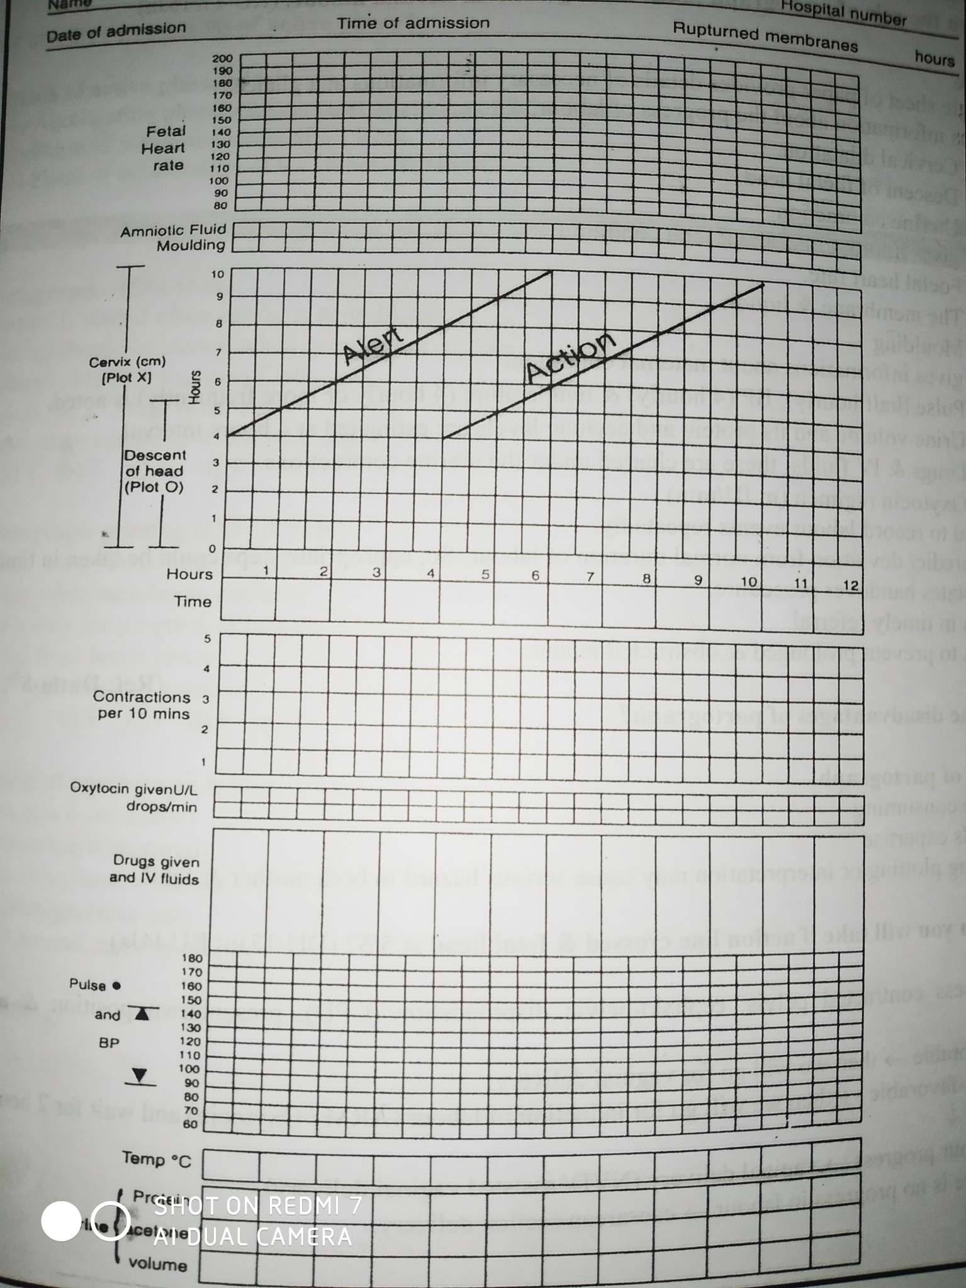

FETAL SKULL AND MATERNAL PELVIS
Areas of the skull
VERTEX : It is a quadrangular area bouned anteriorly by the bregma and coronal sutures behind by the lambda and lamboid sutures laterally by lines passes through the parital eminence.
Brow: It is an area bounded on one side by the anterior fontanelle & coronal sutures and on the other side by the root of the nose and supra orbital ridges on the other side.

Face :It is an area bounded on one side root of the nose and supraorbital ridges & on the other side by junction of the floor of the mouth with neck

Sutures of the skull
- Sagittal suture or longitudinal suture
- Coronal suture
- Lambdoid suture
Importance:
1)Permit gliding movement over the other during moulding of the head in vertex presentation, so diameter of the head become smaller and negotiation of the head through the birth canal becomes easier.
2)Digital palpation of the sagittal suture during P/V examination in labour gives an idea about the manner of engagement , degree of internal rotation of the head & degree of molding of the head can be noticed.
3) In deep transverse arrest, this sagittal suture lies transversely at the level of the ischial spines.

Fontanella:
Flat bones of the vault are united together by non-ossified membranes attached to the margins of the bones .These are called fontanelles . Margins of the bones are called sutures .

Of the many fontanels (6 in numbers) , two are of obstetric significance:
- Anterior fontanel or bregma &
- Posterior fontanel or lambda

Anterior fontanelle /Bregma:
It is a diamond shaped area of unossified membrane formed by the joining of the four sutures in the mid-plane. The sutures are-
- Anteriorly : Frontal suture.
- Posteriorly : Segittal suture.
- Laterally : Coronal sutures on the both sides.
Diameter: Both antero-posterior & transverse diameter are about 3 cm.
Floor: Floor of the anterior fontanelle is formed by a membrane & it becomes ossified 18 months of age after birth & becomes pathological if it fails to ossify even after 18 months.

Clinical importance of anterior fontanelle:
- Palpation of anterior fontanelle on per-vaginal examination denotes the degree of flexion of the fetal head.
- If facilitates molding of the head.
- From it’s position, internal rotation of the head can be assessed.
- As it remains membranous for a long period after birth, it helps in accommodating the rapid & marked growth of the brain .
- Palpation of the floor reflects intracranial pressure status; depressed in dehydration & elevated in raised intracranial pressure.
- Cerebrospinal fluid can be collected through its lateral angles from the lateral ventricles (rarely).
- Collection of blood & exchange transfusion can be performed through it via the superior longitudinal sinus (rarely).

Posterior fontanelle / Lambda: It is triangular shaped depressed area at the junction of the 3 sutures. They are:
- Anteriorly: Sagittal suture.
- Posteriorly: Two lambdoid sutures on both sides. The floor is membranous but becomes bony at term.
Diameter: 1.2 x 1.2 cm.

Occiput: It is an occipital bone. It is denominator of vertex presentation.
Sinciput: It is the area lying in front of the anterior fontanelle & corresponds to the area of brow and it is limited to Frontal bones.

Diameters of fetal skull:
Anterior-posterior of the fetal skull:
Diameters | Extention | Length | Attitude of the head | Prentaton
1)Suboccipitio-brgmatic | From nape of neck to centre of the bregma | 9.5 cm | Complete flexion | Vertex
2)Suboccipitio-fontal | From the nape of back to the ant end of the ant fontanelle or centre of the siciput | 10 cm | Incomplete flexion | Vertex
3)Occipitio-frontal | From the Occiputal eminence to the root of the nose (Glabella) | 11.5 cm | Marked deflexion | Vertex
4)Mento-vertical | From the mid-point of the chin to the highest point of the sagittal suture. | 14 cm | Partial extension | Brow
5)Submento-vertical | From the junction of the floor of the mouth & neck to the highest point on the sagittal suture. | 11.5 cm | Incomplete extension | Face
6)Submento-bregmatic | Extend the junction of the floor of mouth & neck to the centre bregma. | 9.5 cm | Complete extention | Face

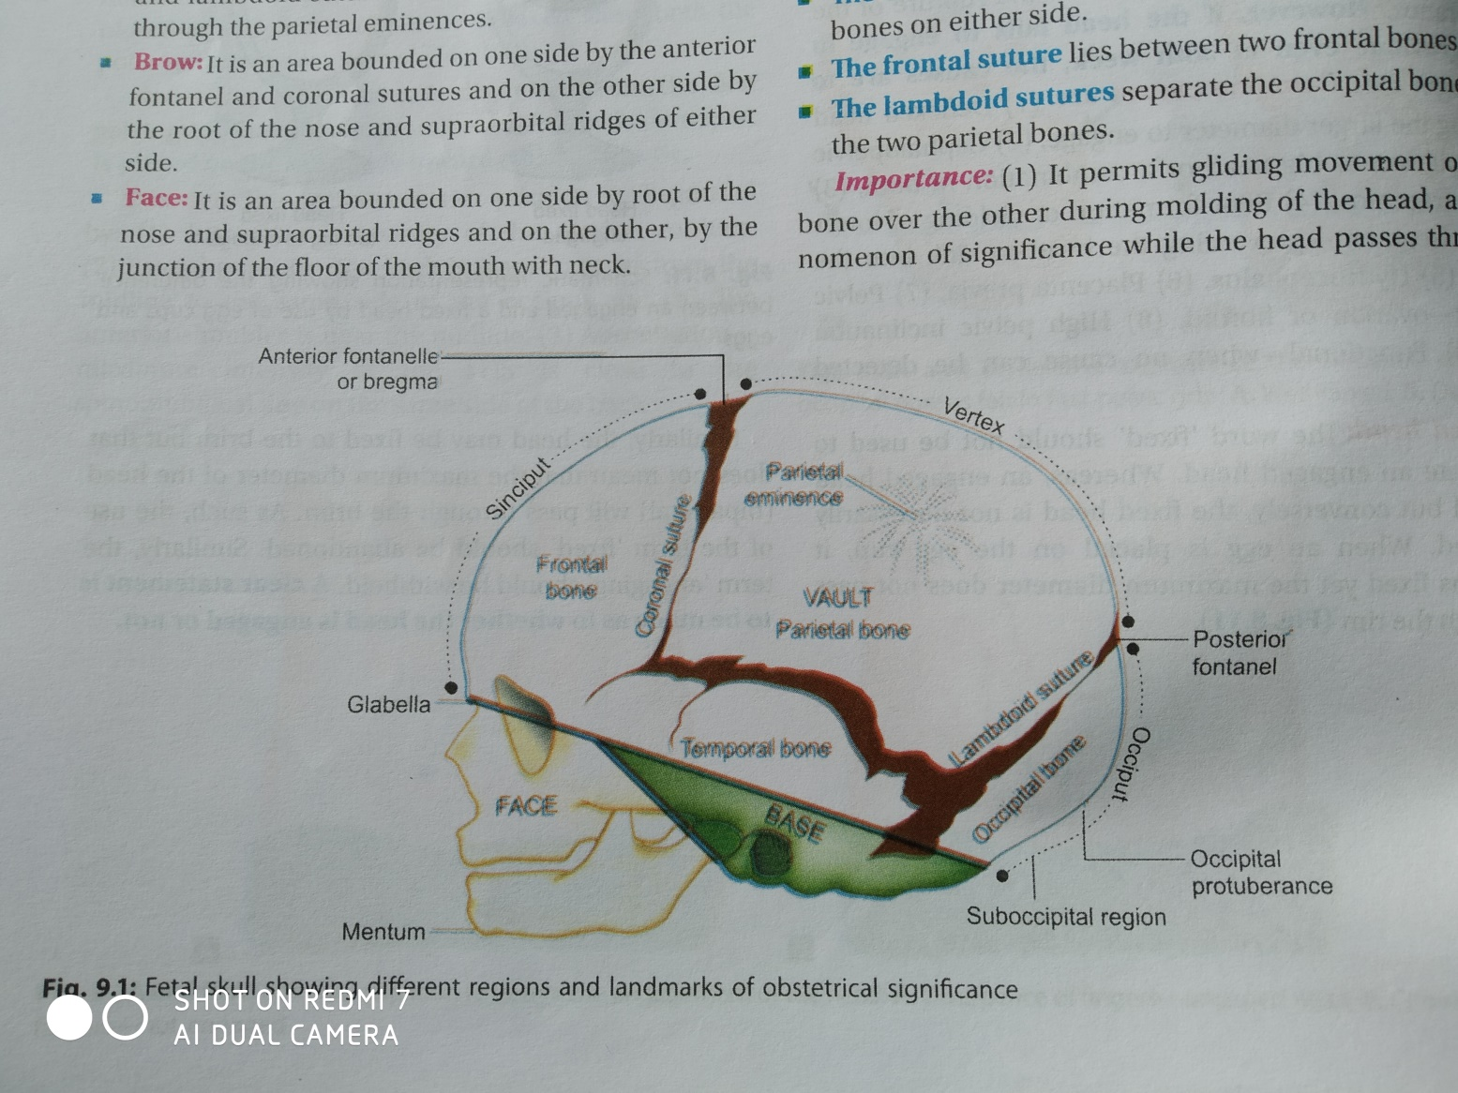

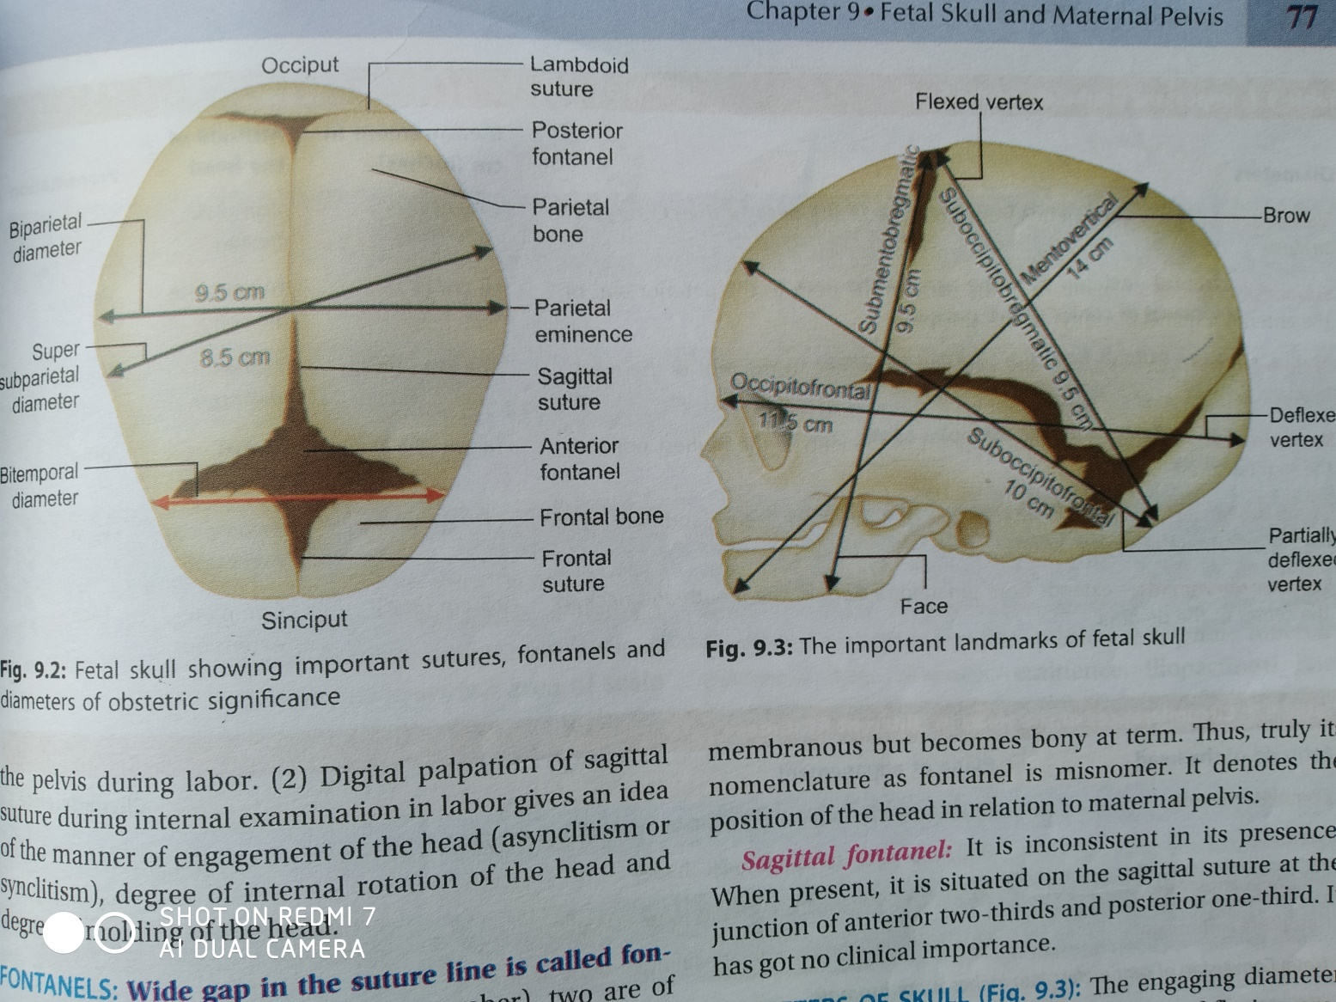

Maternalpelvis: an articluated pelvis consist of four bones two hip bones and sacrum & coccyx
Four joints two sacroiliac –joints, sacro-coccygeal ,one symphysis pelvis .
The pelvis is devied into true & false pelvis.
Bony land marks on the pelvic brim
1)Upper border border of the symphysis pelvis
2)Pubic crest
3)Pubic tubercle
4)Pectineal line
5)Illio-pubic eminence
6)Illio-pectineal line
7)Sacro-illiac articulation
8)Anterior border of the ala of thesacrum
9)Sacral promontory

False pelvis: Pelvis above the line of pelvic brim
Boundery
*Anteriorly: Anterior abdominal wall.
*Posteriorly: Lumber vertebrae
*Laterally :Iliac fossa
True pelvis divided into
*Pelvic inlet
*Pelvic cavity
*Pelvic outlet
Boundery of the pelvic inlet :formed by the boney land marks from anterior to posterior
Shape:Almost round ,AP diameter is short
Diameter.
AP:Between the uppr part of the symphysis pubis to mid point of sacral promontory.
Transverse :Between the farest point of illio pectinial line is 13cm

Diagonal conjugate: is 12 cm lower border of the symphysis to mid point of sacral promontory

Obstetrical conjugate: 10cm,distance between midpoint of the inner surface to the mid point of the sacral promontory.
Pelvic cavity : Bounded above by the pelvic inlet below by the least pelvic diameter.(Inter spinas diameter)
Shape:Almost round
Plane: Mid point of the posterior surface of the symphysis to the 2&3rd sacral vertibra.
Diameter: both AP& Transverse diameter is 12 cm.
Pelvic outlet: above by the least pelvic diameter below by the anatomical outlet.
Shape Anterio-posterior is oval .

Diameter:
AP diameter: From the lower border of the symphysis to the tip of the coccyx.13cm.
Transverse diameter : Between the inner bone of the ischial tuberocites.is11cm.

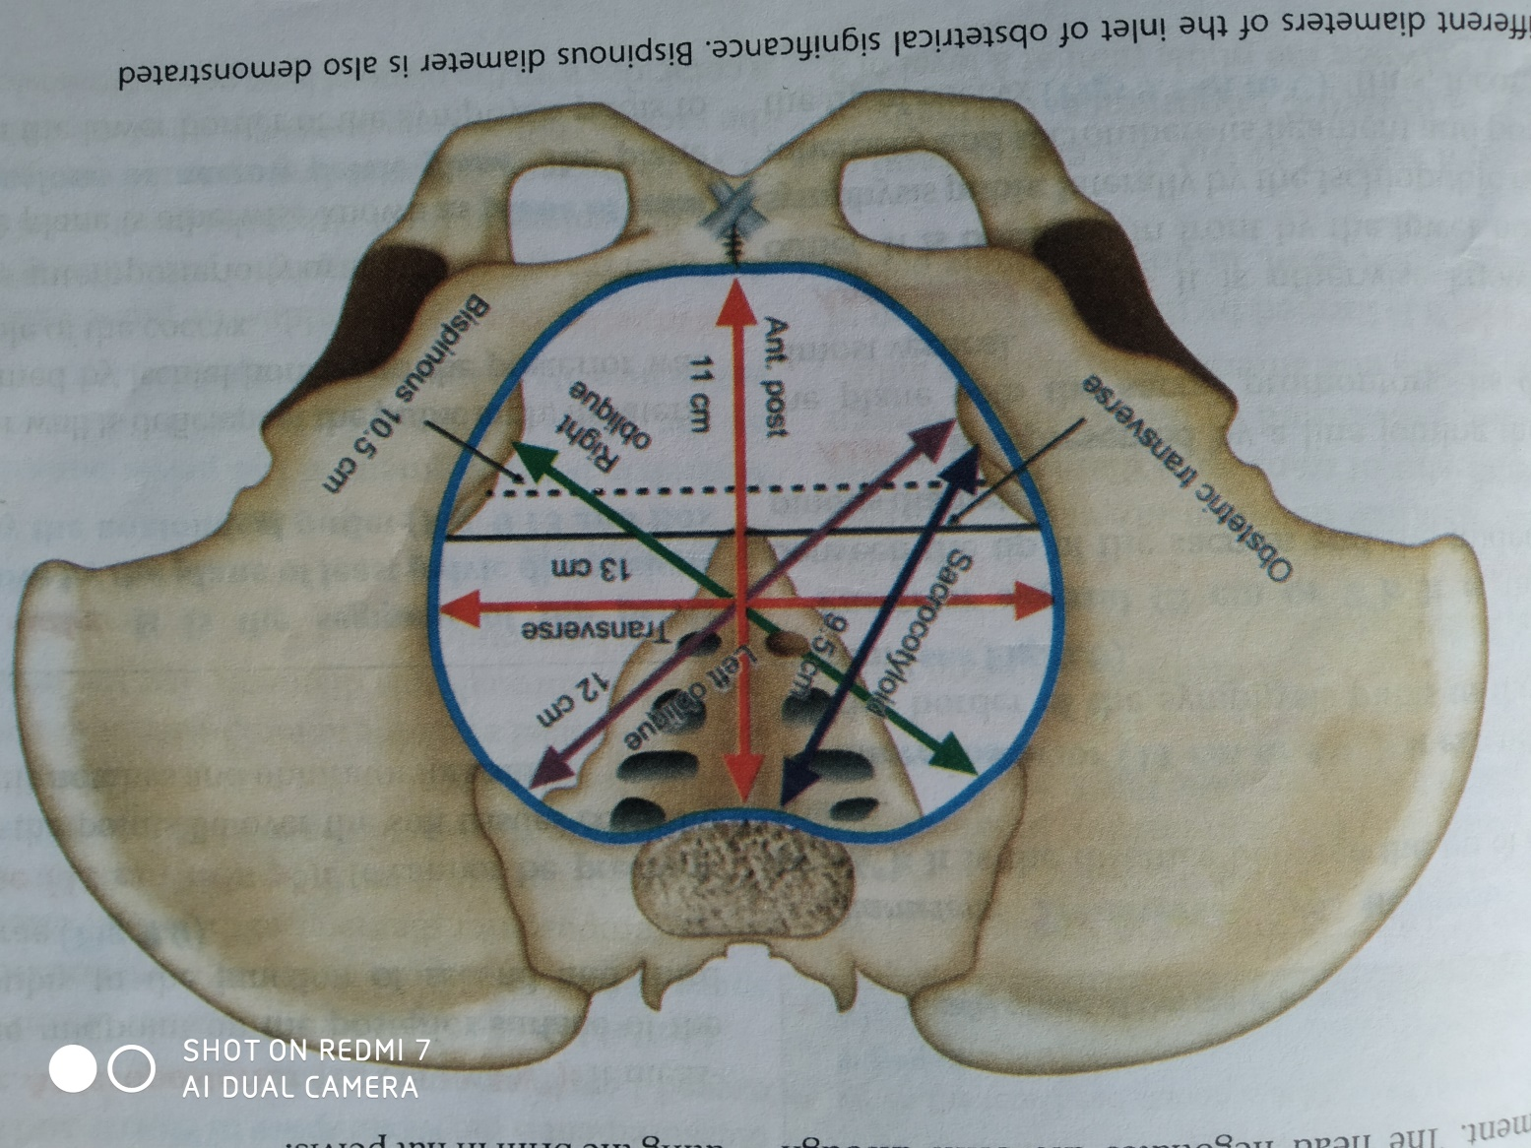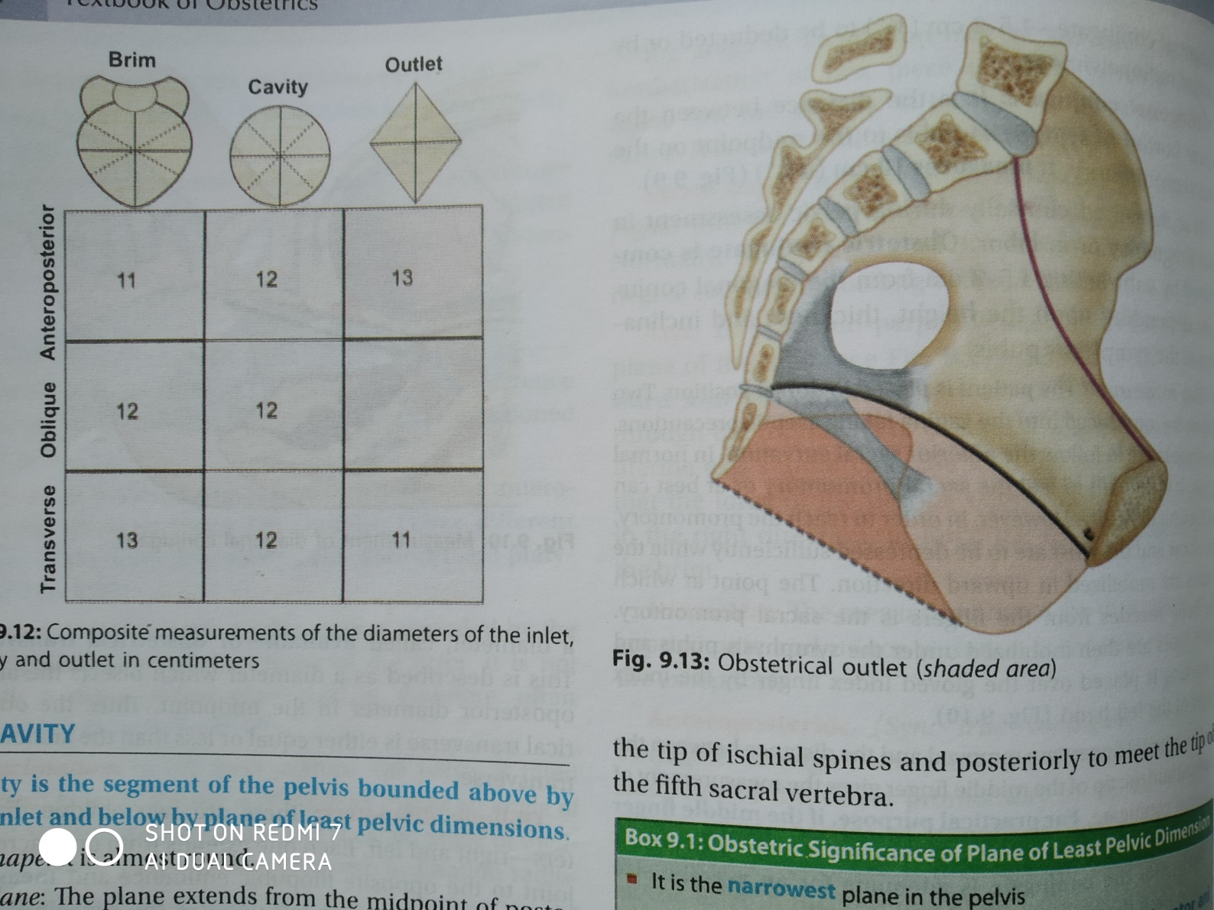

THE FETUS IN UTERO
Lie: The relationship of the long axis of the fetus to the long axis of the centralized uterus or maternal spine.
It may be longitudinal (99.5%),
Transverse or oblique, unstable (0.5%)
Presentation: The part of the fetus which occupies the lower pole of the uterus.
It may be
Cephalic, (96.5%)
Breech(3%),
Shoulder(0.5%)

Presenting part: The part of the presentation which overlies the internal os.
In cephalic presentation the presenting part may may be vertex, brow, or face.

In breech presentation it may be flexed(complete breech)extended(frnk breech),foot may be (footling breech)
Attitude: The relation of the different parts of the fetus to the another is called attitude of the fetus.
It may be flexion, extention.

Denominator:It is an arbitrary bony fixed point on the presenting part which comesin relation with the various quadrtns of the maternal pelvis.
Occiput in vertex,
Mentum in face,
Frontal eminence in brow,
Sacrum in breech
Acromion in shoulder

Position: It is the relation of the denominator to the different quadrants of the pelvis
There are 8 positions
In vertex presentation positions are:

LOT 40%
ROT 24%
LOA 13%
ROA 10%
ROP 7%
LOP 3%
OA 2%
- Op 1%

MULTIPLE PREGNENCY
Multiple Pregnency: When more than one fetus simulteniusly develops in uterus is called multiple pregnancy.
Types of multiple pregnancy:
- Twins
a)Dizygotic (80%)
b)Monozygotic (20%)
2)Triplets
3)Quadruplets
4)Quintuplets
5)Sixtuplets

Incidence:
Twin 1in 80

Causes :
Dizygotic twins related to
- Race
- Hereditary
- Advancing age of the mother
- parity
- Iatrogenic

Difference between Monozygotic& Dizygotic twins.
Monozygotic Dizygotic
1)Children may be same1) Always same sex.
or different sex
2)Different genetic 2)Same genetic mat
material. erial.
3)Separate placenta 3)Usually same placent
4)Separate amnion & 4)Depends on duratin
chorion. of separation.

Management of multiple pregnancy.
Diagnosis
A)History
Race
Hereditary
Advancing age of the mother
parity
Iatrogenic

- Clinical feature
1)Symptoms
-Increase nausea and vomiting

-Increase size of the abdomen
-Cardio respiratory embarrassment
-Swelling of the legs.
2)Signs
-Anaemia
-Weight gain
-Evidence of pre-eclumpsia

3)G/E
Abdominal examination
Inspection: Change to barrel shape
Palpation:
-Height
-Girth
-Foetal parts
-Two foetal heads
Auscultation:
-FHS in 2 sites
P/V Examination:

- Investigation
-Routine examination
-USG
- D/D
- Polyhydramnion
- Big baby
- Fibroidor overian tumor with pregnancy
- Acites with pregnancy

Treatment
- Antenatal Management
1.Dietary advice
2.Rest
3.Supplementation
4.Antinatal visit should be more frequent
5.Fetal monitoring
6.Routine hospital admission
B)Management during pregnancy
a)Advice
b)Hospitalization
1 Elective
2 Emergency

Management during labour
1st stage management
a)Kept in bed if PROM
b)Judicial use of aesthesia
c)Fetal monitoring
d)Open I/V ch annel
e)Keep ready 1 unit of blood.

2nd stage management
A)Delivery of the 1st baby.
a)Presence of Anaesthetist& Neonatologist
b)Close maternal& fetal monitoring
c)If premature episiotomy given
d)1st baby born cord is devide in between 2 clamp.

B)Delivery of the 2nd baby.
a) 1st baby born cord is devide in between 2 clamp.
b)Abdominal exam &detect lie and presentation of 2nd baby.
1)If longitudinal –low ruptured membrane-oxytosic drip-wait 15minutes
-if vertex-NVD-if high up use ventouse
-If breech-breech extraction.
2)If transverse lie –external or internal version –if failC-section.

3rd stage management.
Most dangerous –risk of PPH
-use misoprostol immediately.
-plcenta delivered by control cord traction
-Close monitoring for 2 hours.
-
Complications of Multiple pregnancy:
- Maternal complication:
    - During pregnancy:
-Anaemia (particularly megaloblastic anaemia due to FA deficiency)
-Pre-eclamsia & eclampsia
-Polyhydramnios.
-Antepartum Hge (increased incidence of placenta praevia due to bigger size of the placenta encroaching onto the lower segment)
-Malpresentation (It is quite common more common in 2nd baby)
-Pre-term labour.
-Machanical distress- palpation, dyspnoea, varicosities and haemorrhoids may occur.
  - During labour:
-Early rapture of membranes and cord prolapse.
-Prolonged labour.
-Increased operative interference.
-Bleeding – following the birth of the 1st baby.
-Postpartum Hge – due to
        - Atony of the uterine muscle (due to overdistension)
        - A longer time taken by the big placenta to separate.
        - Bigger surface area of the placenta in the lower uterine segment.
        - Implantation of a part of the placenta in the lower uterine segment.
  - During puerperium:
-Subinvolution
-Infection – because of operative interference, anaemia, bleeding.
-Failing lactation.
- Foetal complication:
-Abortion.
-Prematurity
-Intra uterine death due to
        - cord compression.
        - competition of nutrition.
        - congenital malformation.
-Asphyxia and still births: due to prevalences of toxaemia, malpresentation, separation of placenta and operative interference. 2nd baby is more at risk.

Malpresentation
Breech presentation:
When the lie is longitudinal & the podalic pole presents at the pelvic brim.
It is the commonest mal presentation.
Incidance of breech.
- At 28th week: 20%
- At 34th week: 5%
- At term : 3%
Types of breech presentation
a)Anatomical classification.
b)Clinical classification.
- Anatomical classification
-Complete(flexed breech):The thighs are flexed at hips& the legs at the knees.
Presenting part: Two buttock, two feet,& external genitalia.
-Incomplete breech:
1)Breech with extended legs: Presnting part two buttocks & external genitalia.
2)Footling breech: Presenting part legs
3)Knee presentation : Presenting part knee.
- Clinical classification:
-Uncomplicated.
-Complicated: When the presentation in associated with condition which adversely influence the prognosis, such as prematurity, twins, placenta pravia.

Breech delivery: Aetiology

1)Prematurity(commonest)
2)Factors preventing spontenious version.
-Breech with extended legs.
-Twins.
-Congenital malformation of the uterus.
-Short cord.
-IUD.
3)Favourable adaptation.
-Hydrocephalus
-Placenta pravia
-Contracted pelvis
-Cornu –fundal attachment of the placenta.
4)Undue mobility of the fetus.
-Polihydramnion.
-Multiparity.
5)Fetal congenital abnormalities.
-Trisomies
-Myotonic dystrophy.

Management of breech presentation.
Diagnosis.
- Clinical feture:
-Fundal grif: Globular &hard head felt which is ballotable.
-Lateral grif: Fetal backin one side ,limbs in other side.
-Pelvic grif: Breech is felt.

-Auscultation: FHS usually felt at the level of the umbilicus.

-P/V Ex am : Soft and irregular parts felt through fornix in pregnancy.
-During labour, ischeal tuberosites ,anal opening and sacrum felt.
- Investigations: USG conform the diagnosis.

- Obstetrical management
A)Antenatal management
-Assesment of foetal & maternal wellbeing.
-Identification of the complication factors.
-External cephalic version. if not contraindicated.
-Formulation of line of management.
-If successful—delivery as vertex.
-If fail—vaginal breech by assisted breech delivery or elective caesarean section at 38 weeks.

B)Management in 1st stage.
-P/V exam
-I/V channel is open
-Adequate analgesia
-Monitor the progress of labour
-Oxytocin infusion

C)Second stage of labour
Three methods of vaginal delivery.
a)Spontenious.(10%)
b)Assisted breech delivery.
c)Breech extraction.

D)Management of 3rd stage of labour by active management.

Indication of CS in breech delivery.
- Estimated weight of baby >3.5kg.
- Estimated weight of baby <1.5kg.
- Hyperextension of the head.
- Footling presentation.
- Suspected pelvic contraction.
- Severe IUGR.
- Complicated breech.
Complications of breech delivery.
a)Maternal complications
-Genital tract injury
-Increase rate of operative vaginal delivery
-Increase rate of c-section.
b)Fetal complications.
-Asphysia.
-Injuries
- Haematoma
- Fracture.
- Dislocation.
- Nurve paulsy : Erbs ,Klumpkes paulsy.
c)Intracranial haemorrhage.
d)Cord prolapse.

Delivery of the after coming head of the breech.
This is the most crucial stage of the delivery in assisted breech delivery. The various methods of delivery for the after coming head.
- Burns-Marshal method.
- Forceps delivery.
- Malar flexion &shoulder traction.

Burns – Marshal Method.
1)The baby is allowed to hang by its own weight.
2)Supra-pubic pressure is given for 1-2minutes with the flat hand in a down ward & backward direction by the assistant.
3)When the nape of the neck is visible under the pubic arch, the baby is grasped by the ankles with a finger in between the two.
4)Maintaining a steady traction and forming a wide arch of a circle, the trunk is moved in up ward & forward direction. Meanwhile the left hand to guard the perineum, slipping the perineum off successively the face &brow.
5)When the mouth is cleared off the vulva –no hurry.
6)The trunk is depressed to deliver the rest of the head.

Assisted breech delivery
-The delivery of the fetus is by assistance from beginning to end is called assisted delivery.
-Breech delivery should be conducted by a skilled obstetrician.
-Following are to be kept ready.
1)Anesthatist
2)An assistant
3)Instrument and suture material for episiotomy.
4)A pair of obstetric forceps
5)Paediatrician for management of baby.
Principles of conduction:
1)Never to rush.
2)Never pull from below, but push from above.
3)Always keep the fetus with the back .
* * *

Transverse lie
Transverse lie : When the long axis of the fetus lies perpendicularly to the maternal spine or centralised uterine axis.
Oblique lie: When the fetal axis to the oblique to the maternal spine.
Shoulder presentation: In either transverse or oblique lie ,the shoulder usually presents over the cervical opening during labour.

Positions in transverse lie:
1)Dorso-anterior(60%)
2)Dorso-posterior.
3)Dorso-superior.
4)Dorso-inferior.

Incidence rate: 1 in 200 pregnancy.

Ateology of transverse lie.
1)Multiparty
2)Prematurity.
3)Twins.
4)Polihydromnions.
5)Contracted pelvis.
6)Placenta pravia
7)Pelvic tumours.
8)Congenital malformation of the uterus.
9)IUD

Management shoulder presentation/
Transverse lie.
- Diagnosis.
- Clinical feature and clinical examination.
A)Abdominal examination:
a)Inspection: Uterus looks broader not pyriform.
b)Palpation:
-Fundal height: Less than the period of amenorrhoea.
-Fundal grip: Empty fundal grip, breech or head not felt .
-Lateral grip: Breech felt in one side heard & globular head felt in the other side.
-Pelvic grip :Found empty.

c)Auscultation:
a) Dorso-anterior: FHS usually below the level of the umbilicus.
b)Dorso-posterior: FHS is located at a higher level& often indistinct.

- P/V Ex am :
a)Presenting parts not felt through fornix in pregnancy.
b)During labour, The shoulder is identified by palpating acromion process of the clavicle &axilla.
c)The arm may be found prolapsed
d)Landmarks are the feeling of the ribs and intercostal space.
e)Elongated bag of membranes may felt.

- Investigations:
- USG conform the diagnosis.

- Treatment:
A)Antenatal care & treatment.
-Assessment of foetal & maternal wellbeing.
-Identification of the complicated factors.
-External cephalic version beyond 35 weeks pregnancy, if there is no contraindication.
-If version failed or contraindicated
a) Caesarean section after 37 weeks.
b)Dead or cong. malformed baby – vaginal delivery.
B)Treatment during labour.
a)Early labour
-External cephalic version. if not contraindicated.
-If ECV fails/contraindicated –C section.
b)Late labour
-If baby alive & fetal condition s good—C-section.
-If baby dead-- Destructive operation.

Possible outcome of transverse lie

- Unfavourable(Commonest)/complications.
1)Early ruptured membrane
2)Prolapse of the hand & cord.
3)Fetal death.
4)Dehydration, keto-acidosis, sepsis.
5)Uterine inertia, PPH.
6)Ruptured uterus & maternal death.

B)Favourable (rare)
1)Spontaneous correction
2)Spontaneous expulsion
3)Spontaneous evolution.

- Complications: A series of complications that may arise out of shoulder presentation when the labour is uncared.

A)Maternal complications.
1)Early ruptured membrane
2)Impacted shoulder
3)Obstructed labour
4)Ruptured uterus.
5)Dehydration, keto-acidosis, sepsis.
6)Uterine inertia, PPH
7)Maternal death.
B)Fetal complications
1)Fetal distress.
2)Hand prolapse.
3)Cord prolapse.
4)Intracranial haemorrhage.
5)Fetal injury
*

Antenatal Haemorrhage/APH
Antepartum haemorrhage/APH:Bleeding from or into the genital tract after the28th weeks of pregnancy but before the birth of the baby.
Incidence rate – 3% among the hospital delivery.
causes of APH:
1)Placental bleeding(70%)
-Placenta pravia
-Abruptio-placenta
2)Extra-placental cause(5%)
-Cervical polyp
-Carcinoma cervix
-Local trauma
-varicose vein.
3)Unexplained/idiopathic (25%)

Placenta preavia:
When the placenta is implanted partially or completely over the lower uterine segment is called placenta preavia.
Incidence rate: About one-third of APH due to placenta preavia.
Classification/types/degree.
-Depending upon the degree of extension of placenta to the lower uterine segment.
1)Type 1(Low lying) Major part on the upper segment only the lower margin encroaches in to the lower segment not up to the os.
2)Type11(Marginal): The placenta reaches the margin of the internal os but does not cover it.
It is sub divided into-
-Type11 anterior
-Type11 posterior
3)Type111(Incomplete or partial central):When the placenta covers partially the internal os.
4)Type 1V(central):When placenta completely covers the internal os, even after it is fully dilated.

Clinical classification:
-Mild degree: Type 1 & Type11 anterior.
-Major degree:Type11 posterior, Type 111,&Type1V.
Predisposing factors of placenta pravia:
1)Multiparty,
2)Increase maternal age,
3)History of previous C-section,
4)Any scar in the uterus due to myomectomy & hysterotomy.
5)Placental abnormality(succenturiata)
6)Smoking—causes hypertrophy.

Why Type 11 posterior placenta pravia is major degree?

1)Diminishes the anterio-posterior diameter of the inlet, prevents engagement of the presenting part.
2)Placenta is more likely to be compressed, if vaginal delivery is allowed.
3) More chance of cord compression or cord prolapse.
Why causes bleeding in placenta pravia?
In later months of pregnancy lower uterine segment dilates progressively, but placental grows slowly, inelastic placenta separates the wall of the utero-placental vesselsbleeding. Bleeding is almost always maternal.
Management of placenta praevia :
Clinical features:
History: History of p/v bleeding.
Symptoms:
- The only symptoms of placenta pravia is p/v bleeding
visible b
lood loss. -Sudden onset.
-Painless.
-Apparently causeless &
-Recurrent
Signs:
a)General examination.
-General conditions& anemia are proportionate to the period of gestation.
-Patient is exhausted.
-Cold and clammy skin
-Tachycardia & hypotension.
-Rapid respiration.
-Decrease urine output.
b)Per-abdominal examination
1)Size of the uterus:Propotionate to the period of gestation.
2)Feeling of uterus: Relax, soft and nontender.
3)Presentation: May be abnormal.
4)Foetal head: May be floating
5)FHS: Usually present.

- P/V examination:
P/V exam is contra indicated. Only inspection is possible.

d)Investigations:
1)Ultrasonography
2)Blood for grouping &cross matching.
3)Blood for Hb%.
Treatment: All APH case should be hospitalised and regarded as due to placenta preavia unless proven other wise.
A)Expectant treatment.
a)Bed rest.
b)Periodic inspection
B)Definitive treatment.
a)General treatment.
-Nothing bymouth
-Wide bore I/V canula
-I/V fluids.
-Catheterization.
-Blood transfution.
-Monitoring of vital signs
b)Obstetrical treatment:
1)Without internal examinationC-Section.
2)P/V Exam in OT followed by low rupture membrane or C-section.
Complications of placenta praevia
- Maternal:
A)During pregnancy.
1)Malpresentation
2)Preterm labour.
3)APH with varing degree of shock.
B)During labour.
1)Early ruptured membrane.
2)Cord prolapse.
3)Prolong labour.
4)Intrapartum haemorrhage.
5)Retained placenta.
6)Increase incidence of operative interference
C)During puerperium:
1)Postpartum haemorrhage.
2)Puerperial sepsis.
3)Subinvolution.
4)Embolisom.
- Fetal complications:
1)Low birth weight
2)Asphysia
3)Birth injury.
4)Congenital malformations
5)IUD.

Abruptio placenta.
Abruptio placenta: It is the form of antepartum haemorrhage where the bleeding occurs due to premature separation of normally situated placenta.
Incidence rate: 1 in 150 delivery.
Maternal mortality rte 2-5%
Perinatal mortality rate is 15-20%

Classification
1)Revealed:
-This is the commonest type.
-Following separation of placenta the blood passed downwards between the membranes and decidua .Ultimately the blood comes out of the cervicanal to be visible externally.
2)Conceled:
-This type is rare.
-The blood collects behind the separated placenta or collected between the membranes & decidua. The collected blood is prevented from coming out of the cervical cannel.
-Blood may be percolate in to the amniotic sac after rupturing membrane. So blood is not visible outside.
3)Mixed:
-This type is quite common.
-Some part of blood collect inside& a part is expelled out
-Usually one variety predominates over others.

- Causes of abruption placenta/
accidental haemorrhage.
1)Maternal risk factors.
-Multiparty>4.
-Advancing maternal age.
-Poor socioeconomic conditions
-Malnutrition’s
-Anaemia
2)Hypertension in pregnancy: Pre-eclampsia, eclampsia.
3)Truma
4)Sudden utrine decompression.
-Delivery of the 1st baby of the twin.
-Sudden escape of liquor in polyhydramnion.
-Premature rupture of membrane’
5)Short cord.
6)Supine hypotension syndrome
7)Folic acid deficiency
8)Torsion of the uterus.

Management of abrupsio placenta.
- Clinical features.
A)Symptoms:
-Abdominal pain(severe in concealed)
-Per-vaginal bleeding
-Nausea & vomiting.
-History of pre-eclampsia
B)Signs:
-Pallor, feature of shock & general condition depends on blood loss.
-Vaginal bleeding in revealed type
-Height of the uterus more than the period in conceal type, same in reveal type.
-Feeling of uterus: Woody hard & tender in concealed, normal in revealed type
-Fetal parts :Cannot be felt in concealed type.
-Fetal heart sounds: Usually absent in concealed type.
-Per-vaginal exam: Dark colour bleeding in revealed type & no bleeding in concealed.
- Investigatons:
1)USG
2)Blood for Hb%.
3)Blood grouping& Rh typing.
4)BT,CT,Platelet count.
5)Serum fibrinogen level.
6)Urine: For protein.
- Treatment:
A)General treatment:
1)A wide bore I/V cannula is to be started
2)Continuous catheterization through Foly’s catheter.
3)I/V fluids : Hartman’s solutions’ starts.
4)Blood transfusions.
5)Monitoring the progress of labour: Maternal P,T,BP,urine output,&FHS.
B)Obstetrical treatment:
1)In concealed varity:ARM+Oxytocin(if needed)if there is no responseor fetal distressC-Section.
2)In revealed variety :
a)Patient in labour: ARM +/-oxytocin.
b)Patient not in labour:
- >37 weeks:ARM+/-Oxytocin.
- <37 weeks :
-Contenious P/V bleeding:ARM+/-Oxytocin.
-Bleeding stop :Expectant treatmentTry to continue pregnancy to 37 weeks.
Complications of abruption placenta.
- Maternal complications:
1)Haemorrhage Shock.
2)PPH.
3)Oligouria AnuriaARF.
4)DIC
5)Increased operative interference.
6)Sheehan’s syndrome
7)Psychological upset.
8)Risk of recurrence.
- Fetal complications:
-Birth asphysia.
-Prematurity.
-Fetal death.
* In concealed type25-30%
*In revealed type 50-100%

POSTPARTUM HAEMORRHAGE(PPH)
PPH: Any amount of bleeding from or in to the genital tract following birth of the baby up to the end of the puerperium which adversely affects
the general conditions of the patients evidenced by raise in pulse rate & falling blood pressure is called postpartum haemorrhage.

Classification of postpartum haemorrhage.
- Primary PPH : Bleeding occurs within 24 hours following birth of the baby.
Types of primary PPH.
- 3rd stage bleeding : Bleeding occurs before expulsion of placenta.
- True PPH : Bleeding occurs within 24 hours after expulsion of placenta.
- Secondary PPH: Haemorrhage occurs beyond 24 hours & within puerperium.

Causes of primary PPH:
A)Atonic uterus.
1)Grand multiparae.
2)Over-distension of the uterus :Multiple pregnancy, poly hydromnion & large baby.
3)Malnutrition & anaemia
4)APH
5)Prolonged labour.
6)Malformation of uterus.
7)Mismanaged 3rd stage of labour.
8)Uterine fibroid.
9) Precipitate labour.
10)Use of anaesthetic drugs .

B)Traumatic(20%)
1)Trauma to the genital tract during delivery.
2)Bleeding during C/S.
3)Episiotomy.
C)Mixed : Combination of atonic uterus & traumatic
D)Coagulopathy:
1)Bleeding & coagulation disorder.
2)HELP syndrome.
3)IUD.
4)Abruptio placenta.
5)Jaundice in pregnancy.

Management of 3rd stage bleeding:
Symptoms: Per-vaginal bleeding with visible blood loss after the delivery of the fetus but before the expulsion of the placenta.
Signs:
- General examination:
1)Patient may be exhausted.
2)Lethargic or loss of consciousness in hypo -volaemic or shock.
3)Face: Pallor or even paper white in severe blood loss.
4)Eye ball :Sunken.
5)Tongue: Dry.
6)Hypotension, tachycardia
7)Respiratory distress, tachypnoea.
8)Decreased urine output, even anuria.

B)Per-abdominal examination:
--Uterus may be soft and flabby and becomes hard on massaging.
C)Per-vaginal examination:
1)Active bleeding may be seen on inspection.
2)Clotted blood may be found.
3)Laceration may be present.
4)Placenta remain within the uterus.

- Investigations:
- Blood groping & Rh typing.
- Hb%
- Coagulation profile: BT,CT, Platilet count, prothrombin time
- Ultrasonography

- Treatment
A)Principles of treatment.
--Shout for help
--Imidate resuscitation.
--Replaced of blood.
--Empty the uterus.
---Ensure effective haemostasis.

B)Immediate management:
1)2 Wide bore I/v channel is opened and smarted Ringers lacted solution.
2)Continuous catheterization
3)Blood transfusion
4)I/V broad-spectrum antibiotics.

C)Specific treatment: Removal of placenta.
1)If placenta is separatedRemoval by fundal pressure/controlled cord traction. ,followed by Oxytocin &Misoprotol therapy.

2)If placenta is not separated Manual removal of placenta under G/A ,followed by oxytocin&Misoprostol therapy.

Management of true PPH
- Clinical features:
Symptoms:
1)Patient may be irritable,restless, exhausted or lethargic
2) Per-vaginal bleeding with visible blood loss after the delivery of the placenta.
Signs:
- General examination:
1)Face: Pallor or even paper white in severe blood loss.
2)Eye ball :Sunken.
3)Tongue: Dry.
4)Hypotension, tachycardia
5)Respiratory distress, tachypnoea.
6)Decreased urine output, even anuria.

B)Per-abdominal examination:
--Uterus may be soft and flabby and becomes hard on massaging.
--In traumatic case, uterus is well contracted and hard.
C)Per-vaginal examination:
1)Active bleeding may be seen on inspection.
2)Clotted blood may be found.
3)Laceration may be present.
4)Placenta may be delivered or partially delivered.
- Investigations:
1)Blood groping & Rh typing.
2)Hb%
3)Coagulation profile: BT,CT, Platilet count, prothrombin time
4)Ultrasonography
- Treatment
A)Principles of treatment.
-Diagnose the case of bleeding—atonic or traumatic.
--Immediate resuscitation& correction of hypovolumia.
--Replaced of blood loss.
--Empty the uterus.
---Ensure effective haemostasis.

B)Immediate management:
1)Shout for help.
2) 2 I/v channel is opened by wide bore I/v cannula and smarted Ringers lacted solution.
3)Continuous catheterization
4)Blood transfusion
5)I/V broad-spectrum antibiotics.
6)Monitoring of vital signs.

B)If the uterus is hard and contracted: ExplorationHaemostatic sutures on the tear site.
C) If the uterus is atonic:
1)Palpating the fundus & massaging the uterus.
2) 10 IU oxytocin in 1000 ml Ringers lacted sol.i/v at a drop of 60/min.
3) 800 mcg Misoprostol used P/R.
4)Explore & evacuate the blood clot and placental parts from the uterus.
5)Transfuse blood.
6) If uterus still remain atonic :Bimanual compression.
7) If failsUse condom catheter(Saybas Method).
8)If fails Surgical methods
D) Surgical methods: Stepwise uterine devascularisation.

- Ligation of ascending branch of uterine artery.
- Ligation of the utero-ovariananaestomotic vessels.
- B-Lynch suture.
- If fails Hysterectomy.

Secondary PPH/late post-partum haemorrhage:
PPP : Haemorrhage occurs beyond 24 hours & within puerperium, also called secondary or delayed or late puerperal haemorrhage.
- The bleeding usually occurs between 8th – 14th days of delivery.
Causes of secondary PPH:
- Retained bits of cotyledon or membranes (commonest)
- Infection & separation of slough over deep cervico-vaginal laceration.
- Endometritis
- Subinvolution of the placental site.
- Secondary haemorrhage from caesarean section wound (usually between 10th – 14th days). It is probably due to –
Separation of slough exposing a bleeding vessel or from granuation tissues.
.
- Other Rare Causes:
  - Chorion-epithelioma (occurs usually beyond 4 weeks of delivery).
  - Carcinoma cervix.
  - Placental polyp.
  - Infected fibroid of polyp.
  - Puerperal inversion of uterus.
Management of secondary PPH.
- Clinical features:
Symptoms: Per-vaginal bleeding -Bright red & of varying amount
Signs/ clinical examination:
    - General examination:
      - Anxious looking
      - Face: Pallor (moderate-severe)
      - Sign of anaemia will be preset.
      - Sign of sepsis: High rise of temperature, tachycardia (bradycardia in a sepsis patient is an alarming sign)
      - In septicaemia: Respiratory distress & tachypnoea may be present.
      - Signs of dehydration may be present.

    - Per-abdominal examination:
      - Subinvolution of uterus may be present.
      - Patulous cervical os.
      - C/S wound: Evidence of infection.
    - Per-vaginal examination:
      - Signs of bleeding on inspection.
      - Clotted blood may be found.
      - Signs of laceration in the genital tract &/or perineum may be present.

- Investigation:
- Blood grouping and Rh typing.
- CBC.
- Ultrasonography: For bits of placenta inside uterine cavity.
- High vaginal swab for c/s.
- Treatment
- Principles of treatment:
- Assessment the amount of bleeding & replacement it.
- Finding out the cause & taking specific measures.

- Conservative treatment: If the bleeding is slight & no apparent cause is detected, careful watch for a period of 24 hours or so is done in the hospital.
- Supportive treatment:
- Bed rest.
- Nutritious diet.
- Blood transfusion.
- Antibiotic: Broad spectrum.
- Inj. Ergometrine (0.5 mg) I/M: If the bleeding is uterine in the origin.
- I/V drip with oxytocin,
Use Misoprostol P/R.

- Specific treatment:
- Retain bits of cotyledon or membranes (commonest cause): Exploration of the uterus urgently under G/A. The products are removed by ovum forceps. Gentle curettage is done by using flushing curette. Ergometrine (0.5 mg) is given I/M.
- Secondary PPH following C/S: May require Laparotomy.
- Wound of cervico-vaginal canal: Haemostatic sutures.
- The bleeding from uterine wound can be controlled by haemostatic sutures.
- May require ligation of the internal iliac artery or may end in hysterectomy.
***

